Job Mate – AI-Powered Resume Analysis & Job Matching System

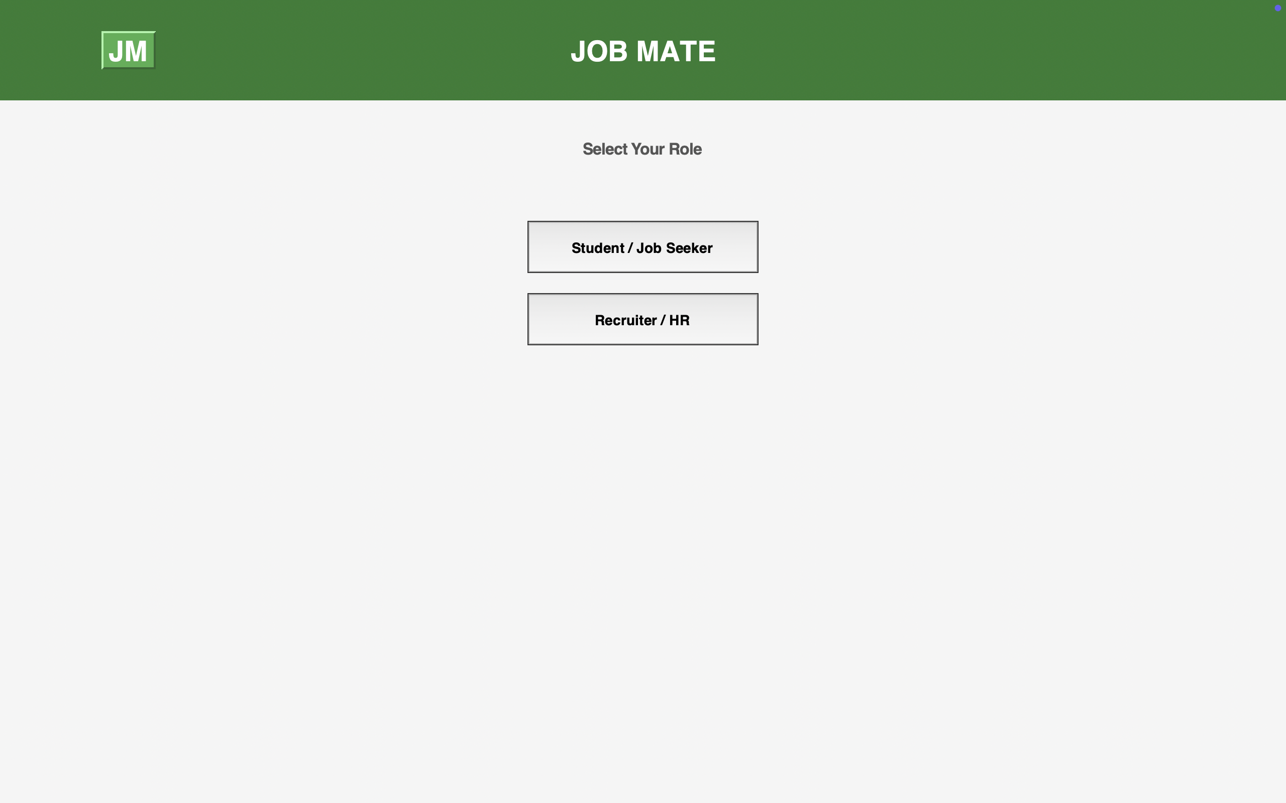

About Project
Job Mate is an intelligent resume analysis and job matching platform that leverages AI-driven algorithms to connect job seekers with optimal career opportunities while helping recruiters identify the best candidates. The system features dual interfaces for job seekers and recruiters, offering comprehensive resume parsing, skills extraction, job role matching, and interview readiness assessment. Built with Python and Tkinter, it provides an intuitive GUI experience with advanced data visualization capabilities using Matplotlib and industry-standard skill benchmarking across multiple job roles.
The platform analyzes resumes using PDF parsing technology, extracts key information including skills, experience, certifications, and contact details, then matches candidates against predefined or custom job requirements. With features like multi-candidate comparison, visual analytics dashboards, and interview readiness scoring, Job Mate streamlines the recruitment process while empowering job seekers with actionable insights for career advancement.

Technologies Used

Core Technologies- Python 3.x • Tkinter • PDFPlumber • Regular Expressions (re) • Pandas

Data Visualization & Analysis- Matplotlib • NumPy • Seaborn • PIL (Pillow)

GUI Components- tkinter.ttk • ScrolledText • Canvas & Scrollbar • FigureCanvasTkAgg

Additional Libraries- os • webbrowser • messagebox • filedialog • ImageGrab

